**Requirements**

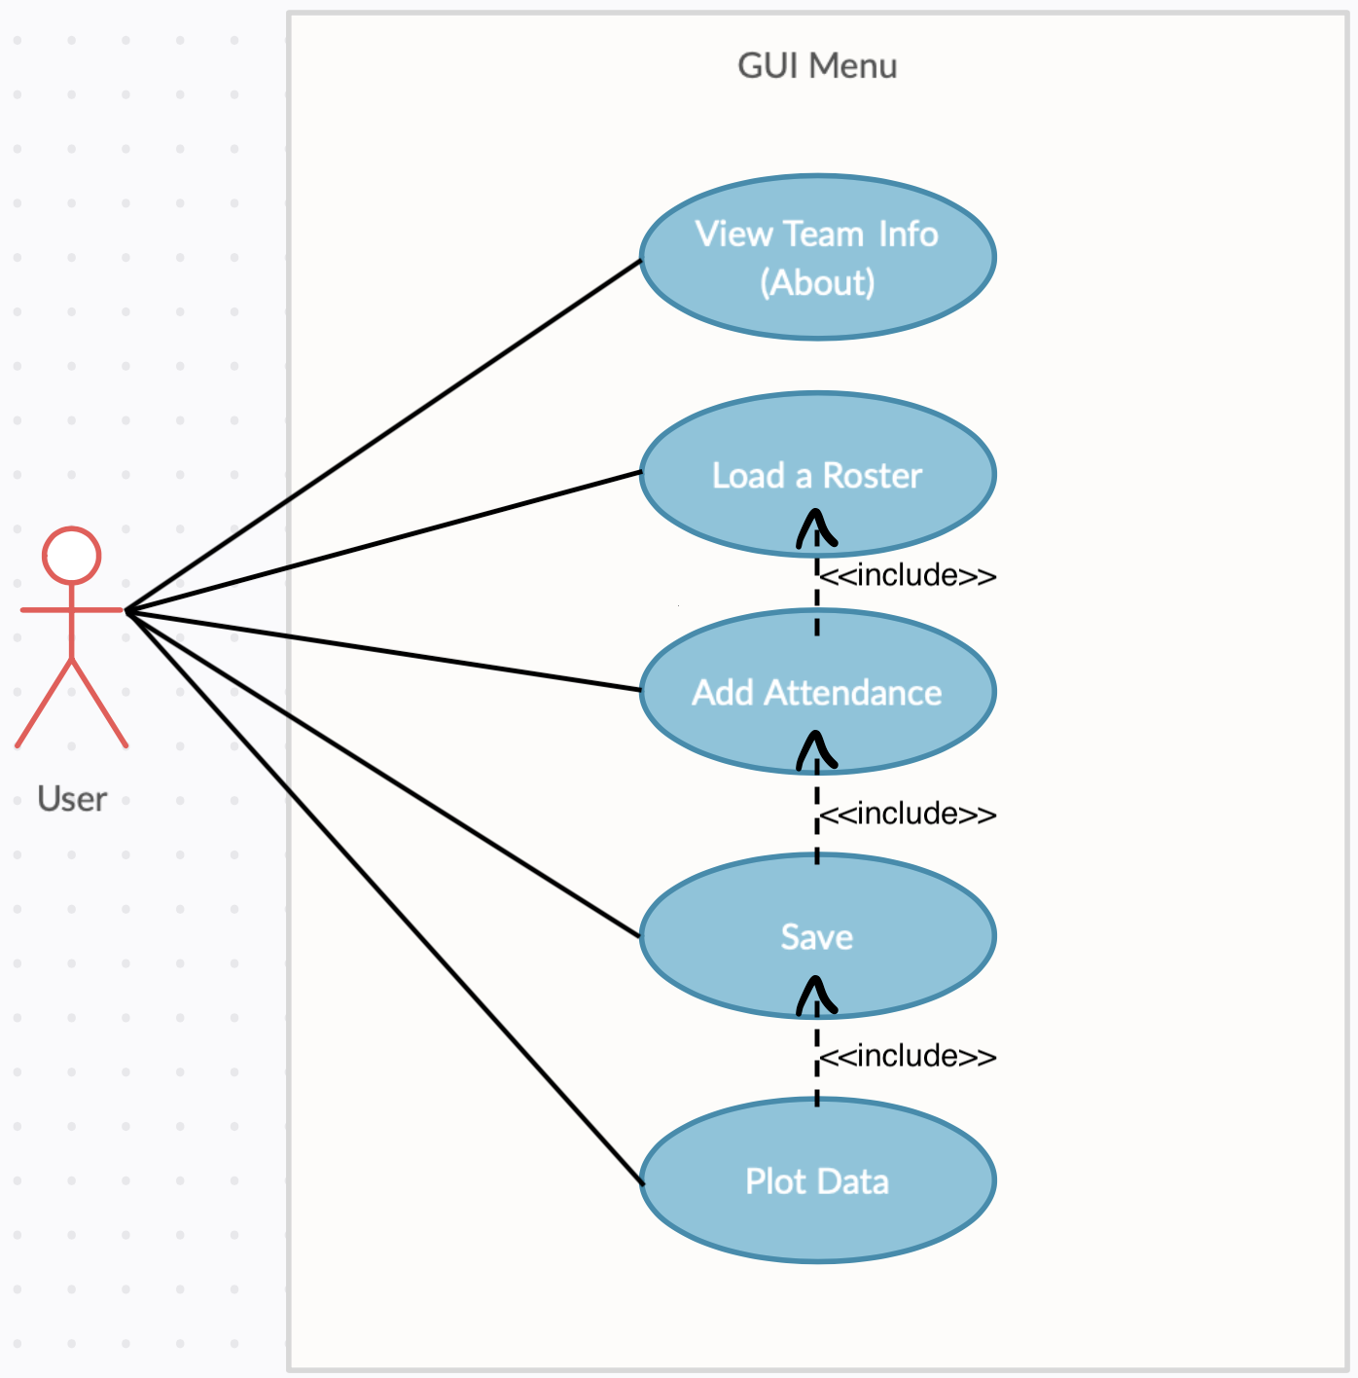

View Team Info: As a user

I want to click on “About” in the menu bar

So I can view the team’s information

Load a Roster: As a user

I want to load a roster

So I can view the data on a Jtable

Add Attendance: As a user

I want to add attendance

So I can view the attendance data on the existing Jtable, now with an additional column of data

Save: As a user

I want to save all data in a CSV file

So I can access all the newly added information at a later time.

Plot Data: As a user

I want to plot the data

So I can view all students’ attendances as a percentage in a scatter plot

**Class Diagram**

**Screenshots**

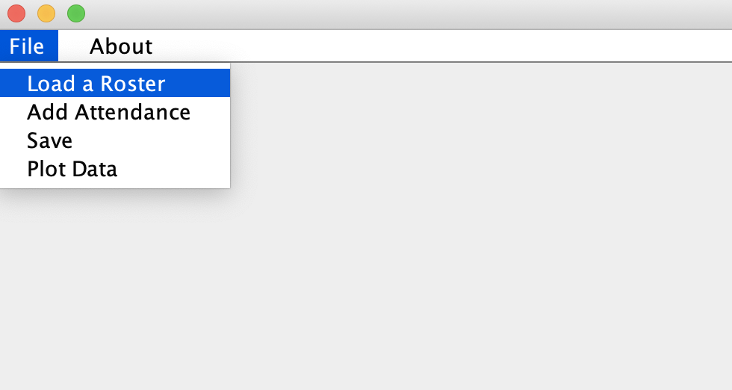

**Testing**

**Project Management**

**PERT/Burndown Chart**